**NATIONAL INSTITUTE OF TECHNOLOGY KARNATAKA SURATHKAL**

**DEPARTMENT OF INFORMATION TECHNOLOGY**

**IT 301 Parallel Computing**

**LAB 7**

**28th September 2021**

**Faculty: Dr. Geetha V Dept of IT**

**NAME: BHUVANESWAR D**

**ROLL NO: 191IT107**

**MPI program 1: Simple Hello World program to find rank and size of communication world. ( 1 Mark)**

#include<mpi.h>

#include<stdio.h>

int main(int argc,char *argv[ ])

{

int size,myrank;

**MPI_Init(&argc,&argv);**

**MPI_Comm_size(MPI_COMM_WORLD,&size);**

**MPI_Comm_rank(MPI_COMM_WORLD,&myrank);**

printf("Process %d of %d, Hello World\n",myrank,size);

**MPI_Finalize();**

return 0;

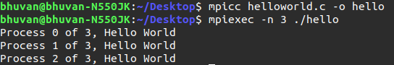

}

**MPI Program 2: MPI_Send() and MPI_Recv() for sending an integer. [Total 3 Marks]**

**(a) Note down source , destination and tag. (1 Marks)**

**(b) Modify the program to send the string “PCLAB” and add screenshot of the result. (1 marks)**

**c) Modify the program to send array of elements and add screenshot of the result. (1 marks)**

#include<mpi.h>

#include<stdio.h>

int main(int argc,char *argv[ ])

{

int size,myrank,x,i;

MPI_Status status;

MPI_Init(&argc,&argv);

MPI_Comm_size(MPI_COMM_WORLD,&size);

MPI_Comm_rank(MPI_COMM_WORLD,&myrank);

if(myrank==0)

{

x=10;

printf("Process %d of %d, Value of x is %d sending the value x\n",myrank,size,x);

**MPI_Send(&x,1,MPI_INT,1,55,MPI_COMM_WORLD);**

}

else if(myrank==1)

{

printf("Value of x is : %d before receive\n",x);

**MPI_Recv(&x,1,MPI_INT,0,55,MPI_COMM_WORLD,&status);**

printf("Process %d of %d, Value of x is %d\n",myrank,size,x);

printf("Source %d Tag %d \n",status.MPI_SOURCE,status.MPI_TAG);

}

MPI_Finalize();

return 0;

}

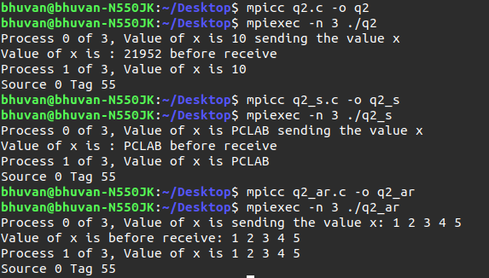

**MPI Program 3: MPI_Send() and MPI_Recv() with MPI_ANY_SOURCE, MPI_ANY_TAG. Note down the results and write your observation. (2 Marks)**

#include<mpi.h>

#include<stdio.h>

int main(int argc,char *argv[ ])

{

int size,myrank,x,i,y;

MPI_Status status;

MPI_Init(&argc,&argv);

MPI_Comm_size(MPI_COMM_WORLD,&size);

MPI_Comm_rank(MPI_COMM_WORLD,&myrank);

if(myrank==0)

{

x=0;

do{

**MPI_Recv(&x,1,MPI_INT,MPI_ANY_SOURCE,MPI_ANY_TAG,MPI_COMM_WORLD,&status);**

printf("Process %d of %d, Value of x is %d : source %d tag %d error %d: \n \n",myrank,size,x,status.MPI_SOURCE,status.MPI_TAG,status.MPI_ERROR);

}while(x>0);

}

else if(myrank>0)

{

y=myrank%5;

printf("Process %d of %d, Value of y is %d : sending the value y\n",myrank,size,y);

**MPI_Send(&y,1,MPI_INT,0,(10+myrank),MPI_COMM_WORLD);**

}

MPI_Finalize();

return 0;

}

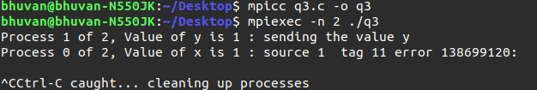**Observation:**

In the MPI_Recv() function, the source parameter is given the value of MPI_ANY_SOURCE which means accept the data from any source and the tag parameter is given the value of MPI_ANY_TAG which means accept the data with any tag value.

**MPI Program 4: MPI_Send() and MPI_Recv() with mismatched tag. Record the result for mismatched tag and also after correcting tag value of send receive as same number (2 Marks)**

#include<mpi.h>

#include<stdio.h>

int main(int argc,char *argv[ ])

{

int size,myrank,x[50],y[50],i;

MPI_Status status;

MPI_Init(&argc,&argv);

MPI_Comm_size(MPI_COMM_WORLD,&size);

MPI_Comm_rank(MPI_COMM_WORLD,&myrank);

printf("Verifying mistag send and receive\n");

if(myrank==0)

{

for(i=0;i<50;i++)

x[i]=i+1;

**MPI_Send(x,10,MPI_INT,1,10,MPI_COMM_WORLD);**

}

else if(myrank==1)

{

**MPI_Recv(y,10,MPI_INT,0,1,MPI_COMM_WORLD,&status);**

printf(" Process %d Recieved data from Process %d\n",myrank, status.MPI_SOURCE);

for(i=0;i<10;i++)

printf("%d\t",y[i]);}

MPI_Finalize();

return 0;

}

**Mismatched tag:**

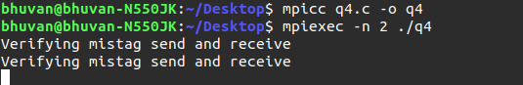

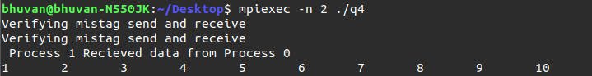**CORRECTED TAG:**

**MPI Program 5: MPI_Send() and MPI_Recv() standard mode:**

**Note down your observation on the content of x and y at Process 1 and Explain the importance of tag. (2 marks)**

/* Demonstration of Blocking send and receive.*/

#include<mpi.h>

#include<stdio.h>

int main(int argc,char *argv[ ])

{

int size,myrank,x[10],i,y[10];

MPI_Status status;

MPI_Request request;

MPI_Init(&argc,&argv);

MPI_Comm_size(MPI_COMM_WORLD,&size);

MPI_Comm_rank(MPI_COMM_WORLD,&myrank);

if(myrank==0)

{

for(i=0;i<10;i++)

{

x[i]=1;

y[i]=2;

}

**MPI_Send(x,10,MPI_INT,1,1,MPI_COMM_WORLD);** //Blocking send will expect matching receive at the destination

//In Standard mode, Send will return after copying the data to the system buffer. The

//call will block if the buffer is not available or buffer space is not sufficient.

**MPI_Send(y,10,MPI_INT,1,2,MPI_COMM_WORLD);**

// This send will be initiated and matching receive is already there so the program will not lead to deadlock

}

else if(myrank==1)

{

**MPI_Recv(x,10,MPI_INT,0,2,MPI_COMM_WORLD,&status);**

//P1 will block as it has not received a matching send with tag 2

for(i=0;i<10;i++)

printf("Received Array x : %d\n",x[i]);

**MPI_Recv(y,10,MPI_INT,0,1,MPI_COMM_WORLD,MPI_STATUS_IGNORE);**

for(i=0;i<10;i++)

printf("Received Array y : %d\n",y[i]);

}

MPI_Finalize();

return 0;

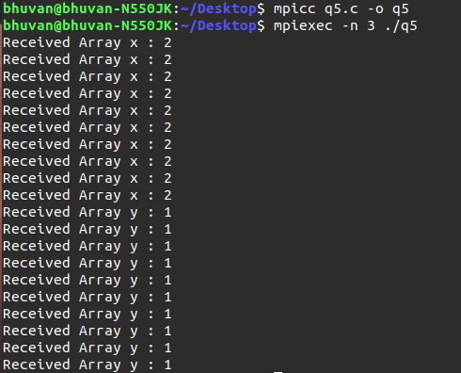}

**Explaination:**

In standard mode, when P1 posts MPI_Recv(), it blocks until x is available in its application buffer. But since

the tags of send and recv are mismatched, P1 enters into deadlock. The 1st MPI_Send() in P0, returns as the

contents of x would reside in the system buffer. Then it posts the 2nd Send(). This tag matches with 1st receive in

P1. So x in P1 would recieve y values and Recv() returns and P1 resumes with 2nd Recv(). This tag matches with

the 1st Send() from P0. So this also executes. Y in P1 has contents of x in P0 and x in P1 Has contents of y in P0.

Tag is a non-negative integer assigned by the programmer to uniquely identify a message. Send and receive

operations should have matching message tags. Mismatch could lead to corrupt data, deadlock.